**TOPIC: GIT & GIT HUB**

**Use GIT as local VCS. Steps to follow:**

* Create a directory ‘project_dir’ & cd to ‘project_dir’.
* Initialize git version database. (**git init**)
* Create a new file index.html.
* Check the git status. You should find index.html as untracked file.
* Stage the index.html file.
* Commit index.html
* Make few changes in index.html & create a new file info.txt file.
* Check git status. You should find index.html & info.txt as untracked files.
* Configure GIT to ignore all txt files.
* Again, check the git status. You should find only index.html as untracked file.
* State & commit index.html
* Log all your comments so far.
* Make some changes in index.html.
* Revert the change made in the previous step using git command.
* Again change index.html.
* Stage index.html
* Revert back the last stage.
* Rename ‘add’ command to ‘my-add’.
* Using my add command Stage index.html again & commit the changes.
* Revert the last commit.

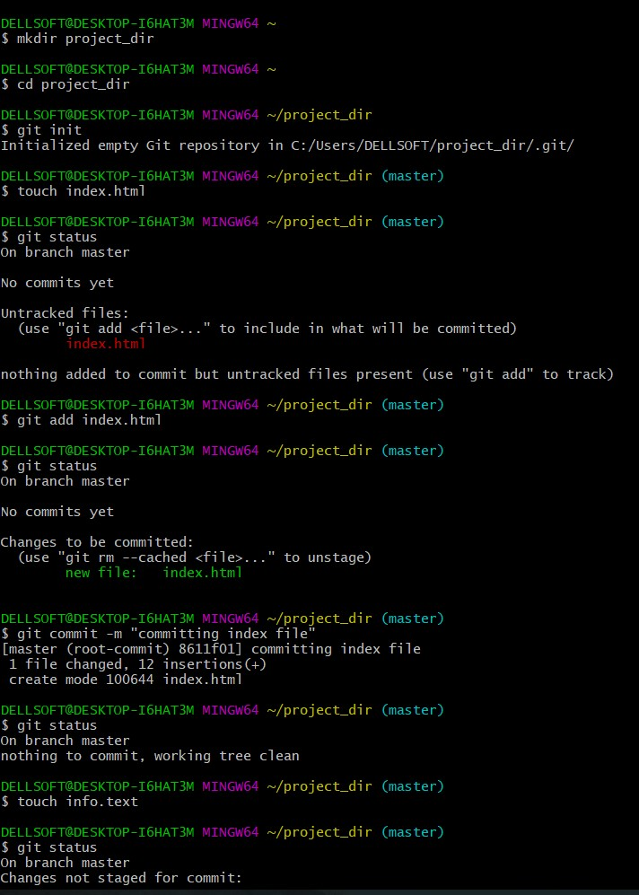

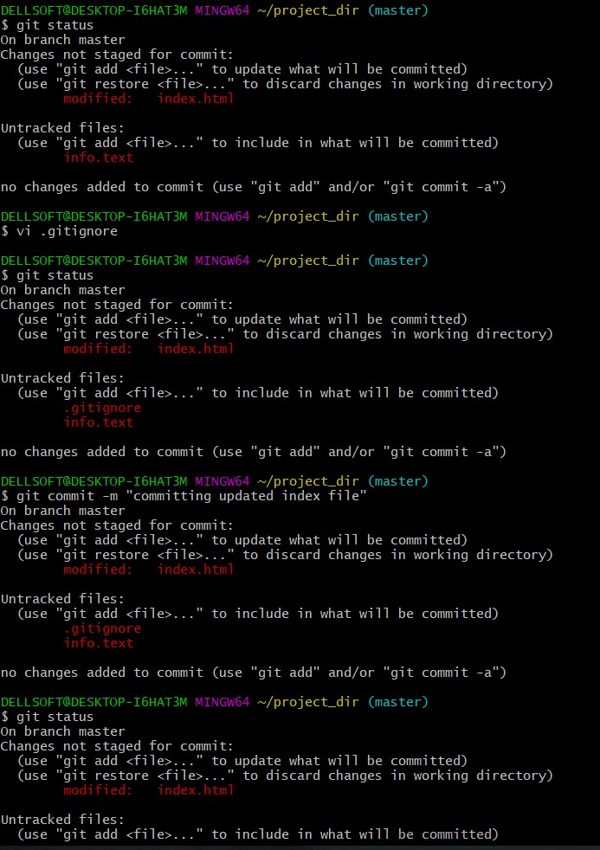

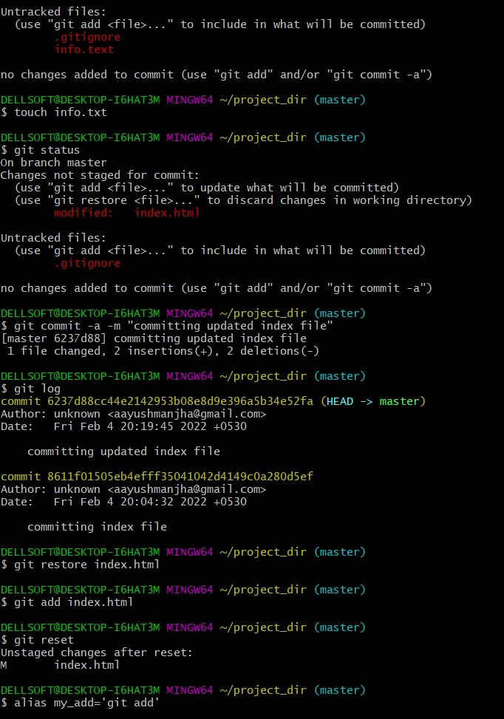

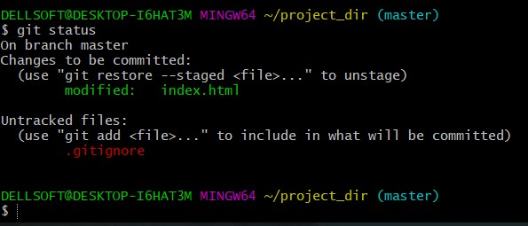

**GIT BRANCHING**

Objective: Commit HTML, CSS & JavaScript assignments into GIT.

SECTION-1 (HTML assignments) - Steps to follow:

* 21. First take a backup of your assignments & projects. This is required because due to incorrect GIT operation you may lose your files.
* 22. Create an empty directory ‘Assignments’ & cd to ‘Assignments’.
* 23. Create a file README.txt inside ‘Assignments’ & write few lines about the contents of ‘Assignments’ folder.
* 24. Commit README.txt file.
* 25. Now create a new branch ‘html-assignments’.
* 26. Switch to ‘html-assignments’ branch.
* 27. Copy all HTML assignments inside ‘Assignments’ folder.
* 28. Commit HTML assignments into ‘html-assignments’ branch.
* 29. Make minor changes into few files belonging to ‘html-assignments’ branch.
* 30. Commit those changed files.
* 31. Switch to master branch.
* 32. Make minor changes into README.txt file & commit those changes into master.
* 33. Again switch to ‘html-assignments’ branch.
* 34. Make minor changes into few files belonging to ‘html-assignments’ branch.
* 35. Commit those changes.
* 36. Switch to master.
* 37. Merge ‘html-assignments’ branch into master. Confirm all html assignments are shown in master.
* 38. Finally delete the ‘html-assignments’ branch

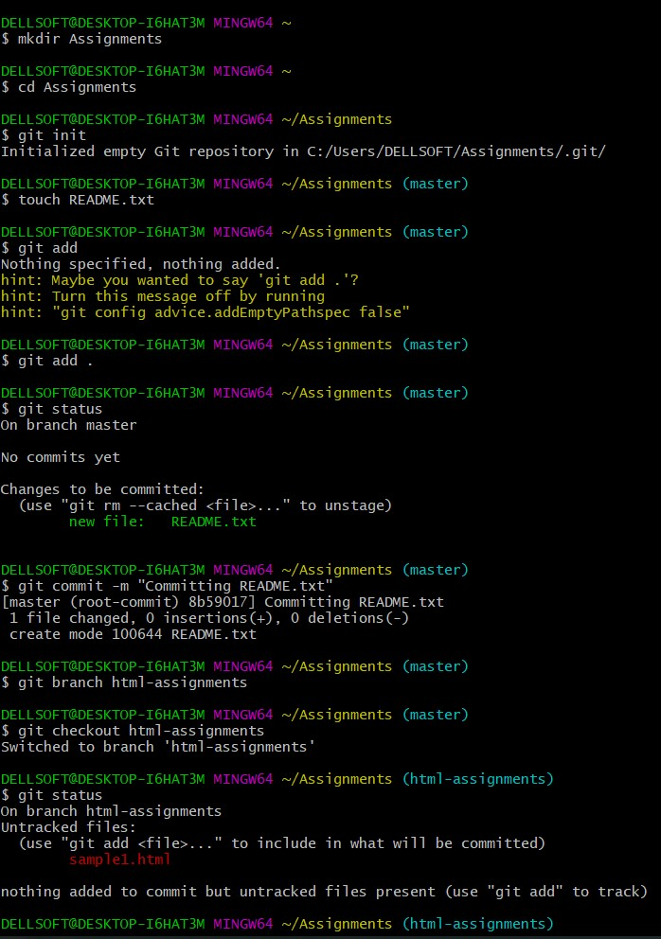

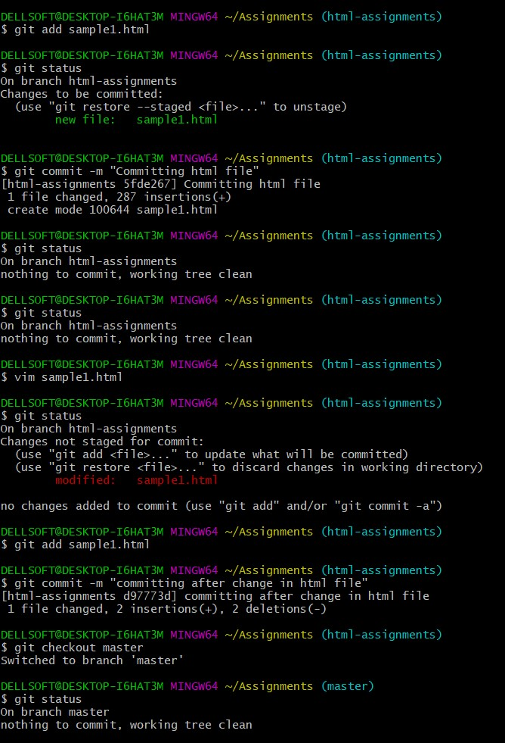

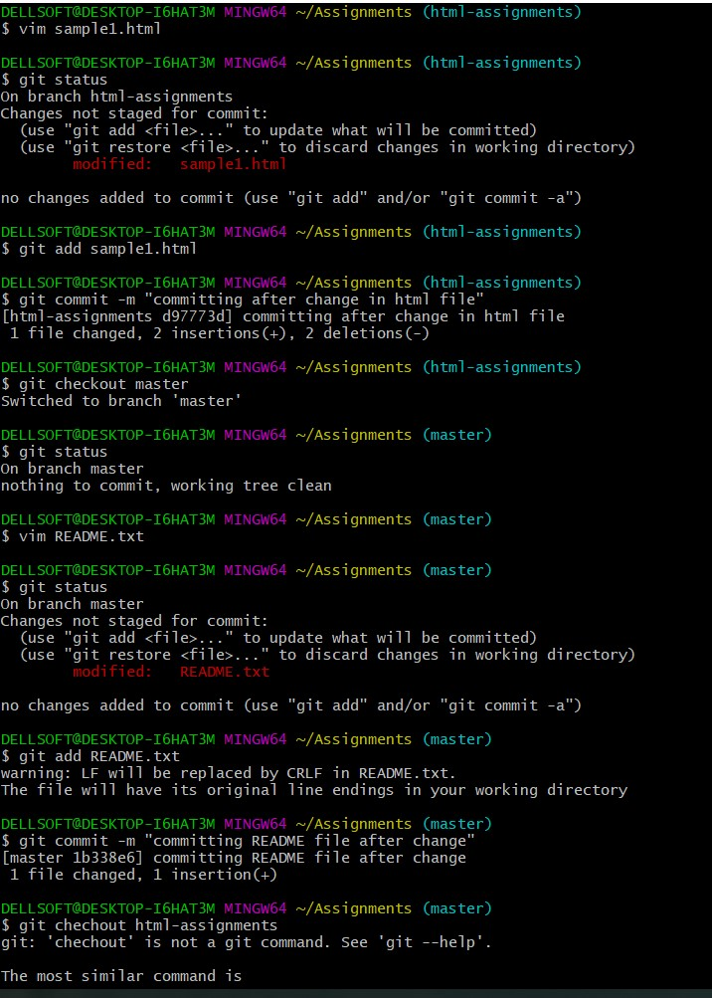

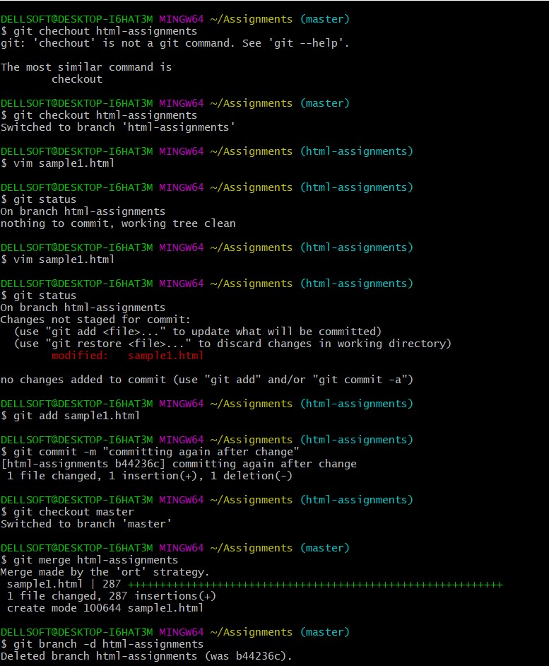

***SECTION-2 - (CSS assignments)***

Steps to follow:

* Create a new branch ‘css-assignments’.
* Switch to ‘css-assignments’ branch.
* Copy all CSS assignments inside ‘Assignments’ folder.
* Commit CSS assignments into ‘css-assignments’ branch.
* Make minor changes into README.txt file on line 1 belonging to ‘css-assignments’ branch.
* Commit those changed files.
* Switch to master branch.
* Make minor changes into README.txt file on line 3 & commit those changes into master.
* Again switch to ‘css-assignments’ branch.
* Make minor changes into few files belonging to ‘css-assignments’ branch.
* Commit those changes.
* Switch to master.
* Merge ‘css-assignments’ branch into master. Confirm all css assignments are shown in master
* Finally delete the ‘css-assignments’ branch

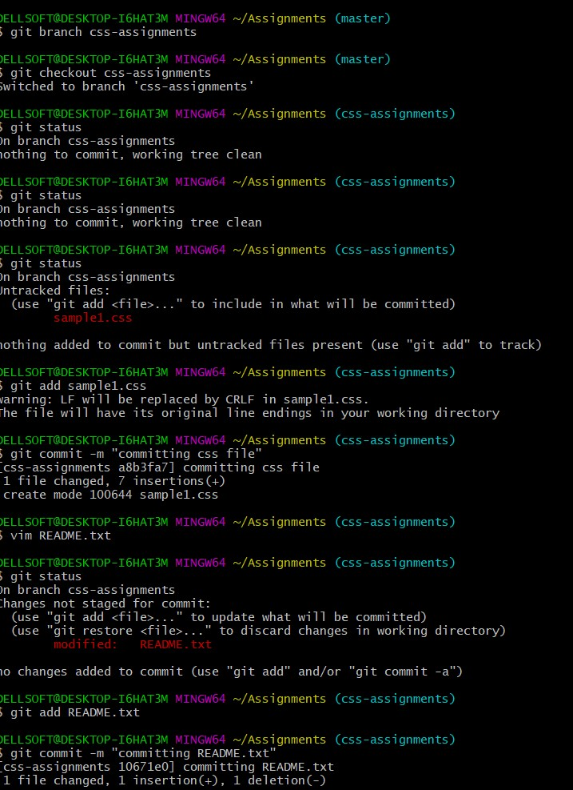

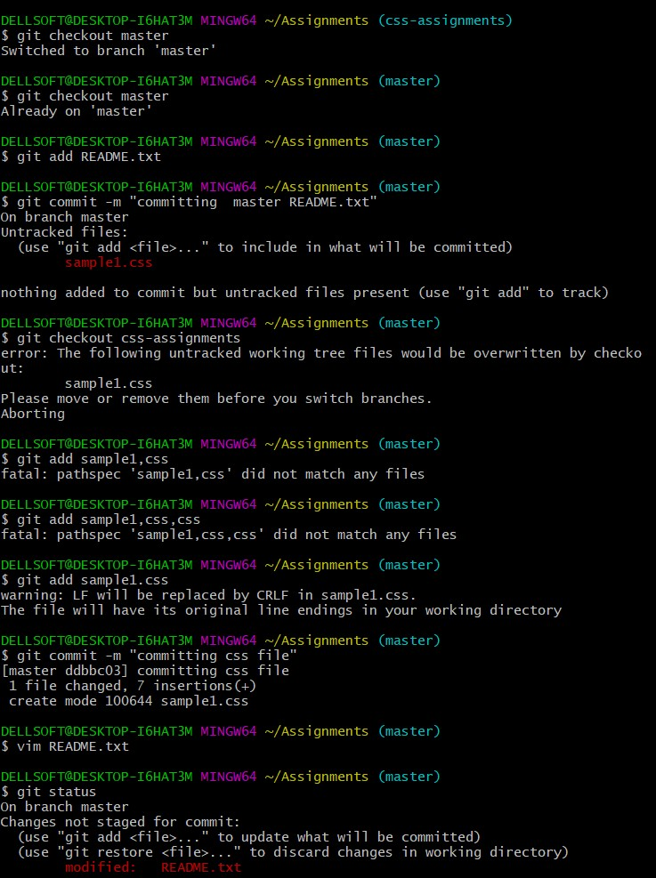

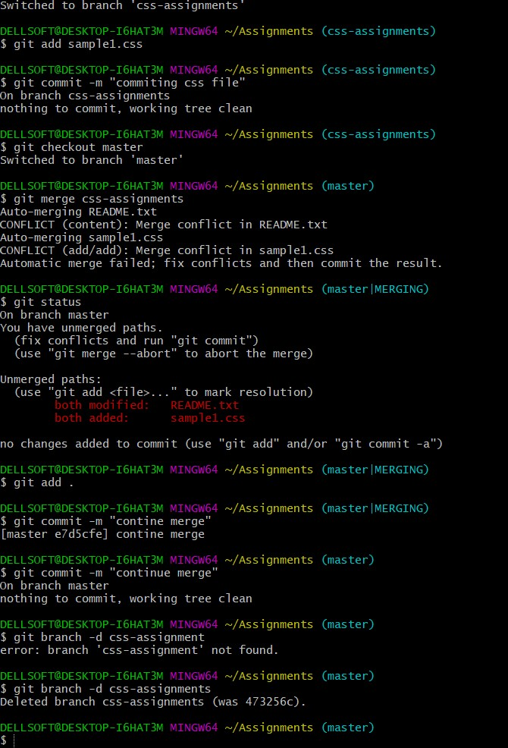

**SECTION-3 - (JavaScript assignments)**

Steps to follow:

1. Create a new branch ‘js-assignments’.

2. Switch to ‘js-assignments’ branch.

3. Copy all JavaScript assignments inside ‘Assignments’ folder.

4. Commit JavaScript assignments into ‘js-assignments’ branch.

5. Make minor changes into README.txt file on line 1 belonging to ‘js-assignments’ branch. 6. Commit those changed files.

7. Switch to master branch.

8. Make minor changes into README.txt file on line 1 & commit those changes into master. 9. Again switch to ‘js-assignments’ branch.

10. Make minor changes into few files belonging to ‘js-assignments’ branch.

11. Commit those changes.

12. Switch to master.

13. Merge ‘js-assignments’ branch into master. Confirm all JavaScript assignments are shown in master.

14. Finally delete the ‘js-assignments’ branch.

